Come and Join
Our 11-day Pilgrimage to
DALMATIAN SUNSHINE
& OBERAMMERGAU
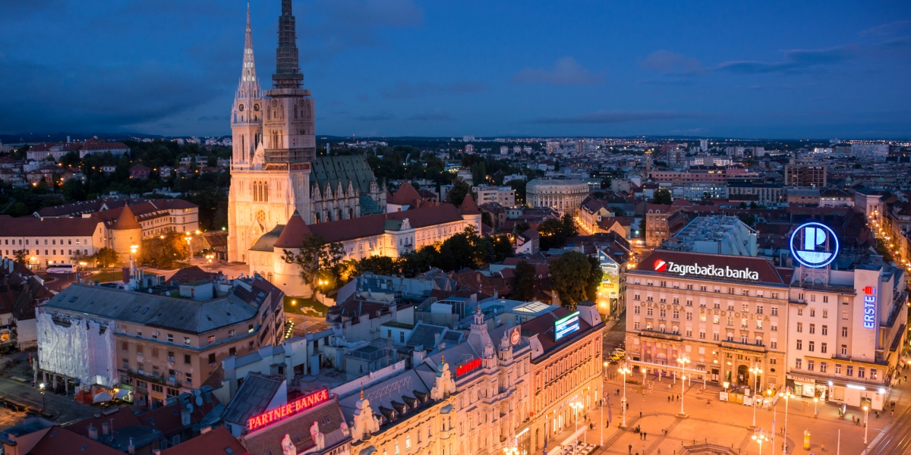
PASSION PLAY
FR. JOSE ERLITO EBRON
(Spiritual Chaplain)
June 28 – July 8, 2020
$4,299 from EWR

Included
Oberammergau ticket and accommodations (as indicated)
Hotel accommodations during pilgrimage (dbl occ)
Breakfast and dinner daily (except as noted)
Deluxe motor coach & Professional Escort and Local Guides
All entrance fees to the sites as specified in itinerary

Not Included:
Airfare w/ Airport tax (published 11 months before departure)
Tips to Guides and Driver ($10 per day) pre-collected
Travel Insurance covering cancellation, interruption, delay, health, accident, etc. with non-refundable premium: $239 for $3000 trip cost 0r $316 for $4000 trip cost or $397 for $5000 trip cost.
Drinks during meals & Personal extras
Single (in a room) Supplement is $565

190329
For More Information, please contact:
Noelette Tours 845 323 4522 or 845 634 5746
Email: sales@noelette.com Website: www.noelette.com
- SOLANDRA WAY, TEGA CAY, SC29708
NOTE: Depending on local conditions, itineraries may change to maximize visits to the sites. Limited Oberammerau tickets to 36 seats.

ITINERARY

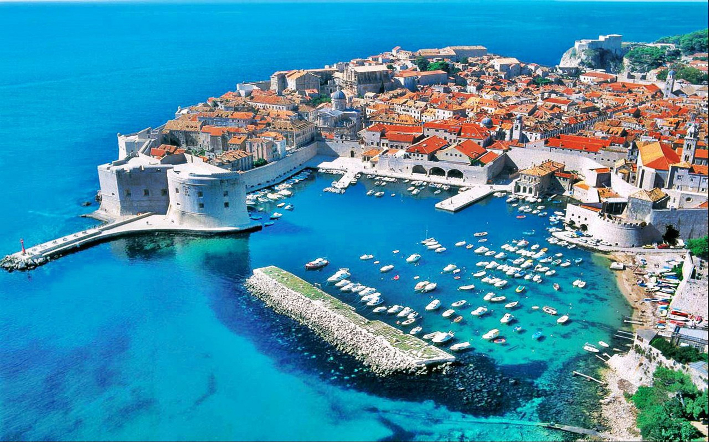
Day 1: TRANSATLANTIC FLIGHT
Depart USA airport for transatlantic flight.

Day 2: ARRIVE DUBROVNIK
You will be met and transferred to your hotel. The rest of the day is at leisure. Tonight, gather with your Tour Director and fellow travelers at a Welcome Dinner. (D)

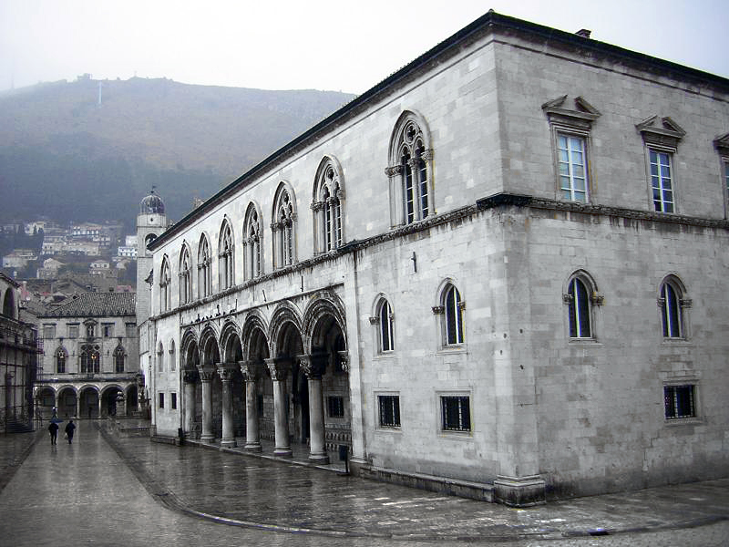
Day 3: IN DUBROVNIK
On a morning walking tour of Old Dubrovnik visit the Rector's Palace, and see the Bell Tower Clock, Orlando's Column, Sponza Palace, the Dominican Monastery, and Franciscan Monastery with its Pharmacy, one of the oldest in the world. The rest of the day is free. Diner, overnight. (B,D)

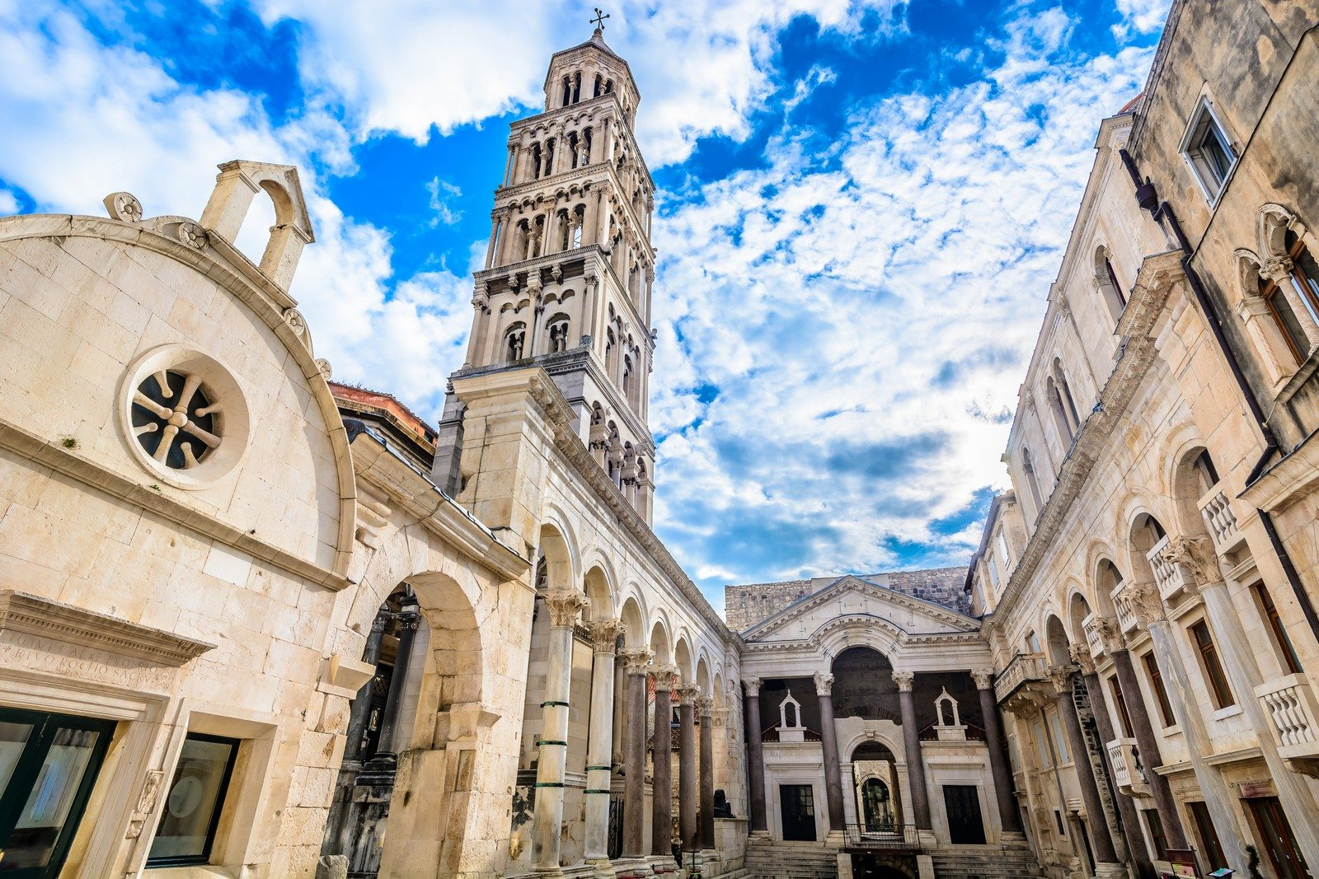
Day 4: TO SPLIT
Travel north along the spectacular Adriatic coast, past old fishing villages and new resorts, to the city of Split. Enjoy a sightseeing tour featuring the historic inner city, built around the Roman Emperor Diocletian's Palace, a UNESCO World Cultural Heritage site. Then see the remnants of Split's Roman heritage, its Renaissance and Gothic structures, Jupiter's Temple, the Peristyle, and the Cathedral. (B, D)


Day 5: TO TROGIR & PLITVICE LAKES
After breakfast, head to Trogir, the center of artistic activities. Scholars from around the world gather here to study and paint. Then, turn inland and travel to spectacular Plitvice Lakes National Park. Have your camera ready as you take a walking tour around several of the lower lakes. Enjoy the breathtaking scenery of this natural wonder of 16 terraced lakes surrounded by thickly wooded mountains and lush vegetation. (B, D)

Day 6: TO OPATIJA, POSTOJNA & BLED
Return to the coast and travel along the beautiful bay of Kvarner to its popular resort, Opatija. After some free time, journey north to Postojna, home to one of the largest caves in Europe. Tour this fantastic subterranean world by miniature electric train. Afterward, continue to Bled, beautifully set in the Julian Alps. (B, D)

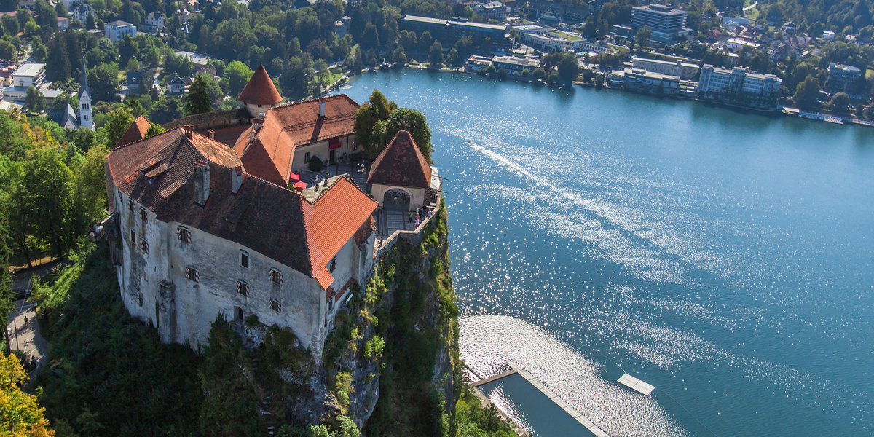
Day 7: IN BLED
An Alpine lake surrounded by high peaks, Bled was “discovered” by travelers in the middle of the 19th century. Since then, a small town of hotels, villas, and restaurants has developed around the lake, turning Bled into a lively, all-seasons resort. A sightseeing tour features the charming town and the lakeshore, and visits imposing Bled Castle, perched on a cliff high above the lake. The balance of the day is at leisure. Perhaps join an optional excursion visiting the small island in the middle of the lake, browse through the shops and boutiques, or simply relax and enjoy the enchanting scenery. (B,D)

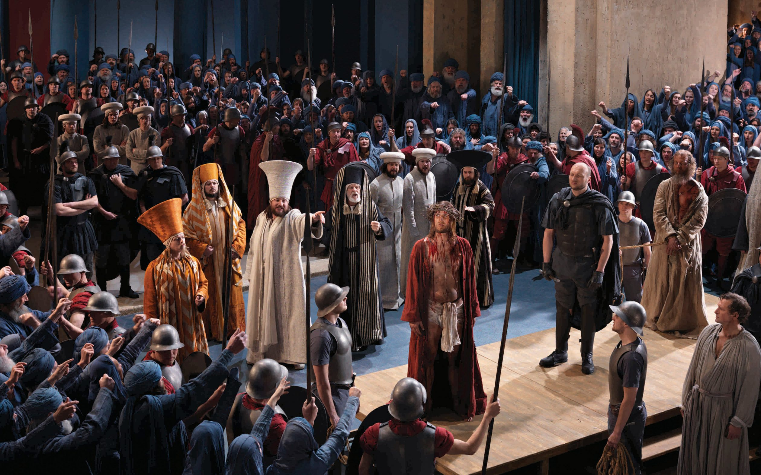
Day 8: BLED - OBERAMMERGAU
After early breakfast, travel to Oberammergau. Upon arrival check in at the hotel. Afternoon attend to Passion Play Full performance. 1st part starts 1:30/ 2:30 PM, 2nd part starts 7/8 PM. Three course dinner will be served at a designated restaurant in Oberammergau during the intermission. Overnight (B)

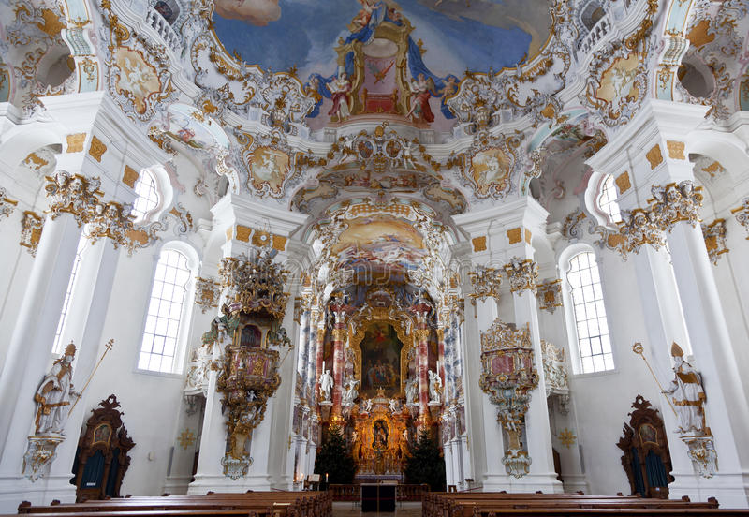
Day 9: TO NEUSCHWANTERIN, WIES & MUNICH
Morning drive along Alpine roads to Fussen and view the Castle of Hohenschwangau. Then we proceed to the most Famous Castle in Europe “Neuschwanstein Castle”, built by King Ludwig II. A visit to the Castle that inspired Disney’s to build the Magic Kingdom castle. Then drive to Wies to visit the Church built in 1746. The Wies Kirche has been described as the most beautiful Rococo Church style in Europe. We continue to Munich for dinner and overnight. (D)
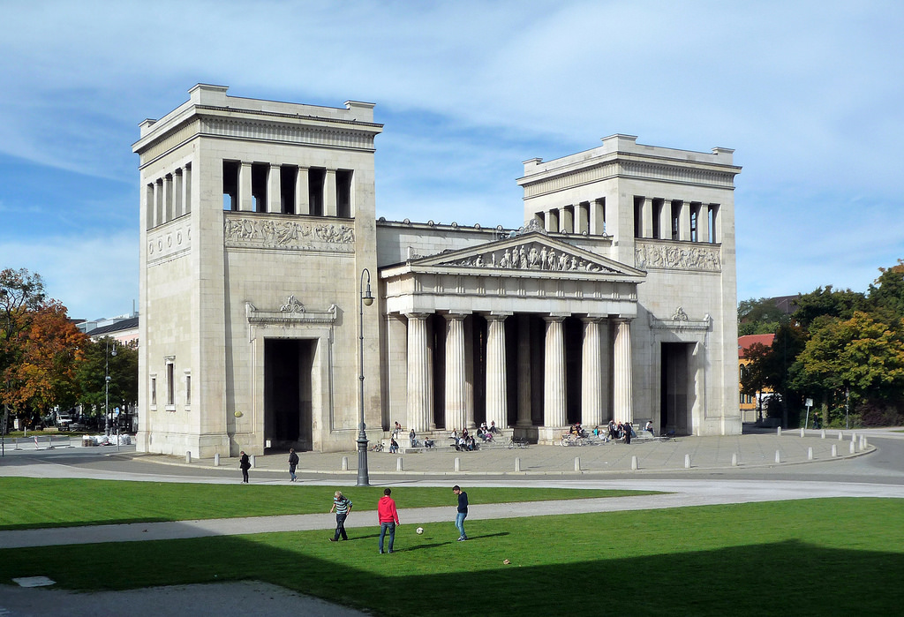
Day 10: MUNICH
After breakfast, enjoy this morning a city tour of downtown Munich, including views of the Koenigsplatz, old and new Pinakotek, the Isartog (City Gate), the Royal Palace, The Angel of Freedom and Odeonsplatz. The reminder of the day is at leisure. Farewell Dinner at a local restaurant. Overnight. (B, D)

Day 11: DEPART MUNICH - After breakfast, you will be transferred to the airport for your departure flight.
190329
Noelette Tours 845 323 4522 or 845 634 5746
Email: sales@noelette.com Website: www.noelette.com
807 SOLANDRA WAY, TEGA CAY, SC29708

